Insertion Sort
In this technique we pick an element and then insert it at the appropriate position in ascending or descending order.
If we have n elements then it requires (n-1) pass/round to sort.
In pass 1 , elements a[1] is inserted either before or after a[0] so that a[0] and a[1] are sorted.
In pass 2, a[2] in inserted either before a[0] or between a[0] and a[1] or after a[1] so that a[0], a[1] amd a[2] are sorted.
In a similar way the process is carried out n- times.

Example:
Consider an array arr having 5 elements
5 4 3 1 2
Arrange the elements in ascending order
We have 5 elements so we need max. 4 pass to sort the elements.
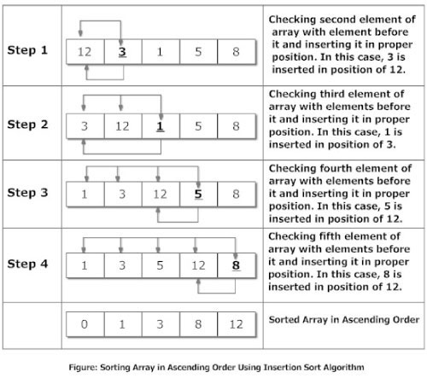

Insertion Sort:

#include<stdio.h>

#include<conio.h>

void main()

{

int a[100],i,j,n,k,temp=0;

clrscr();

printf("How many no. you want to read\n");

scanf("%d",&n);

for(i=0;i<=n-1;i++)

{

printf("Enter %d Element in array\n",i);

scanf(" %d",&a[i]);

}

for(i=1;i<=n-1;i++)

{

k=i-1;

for(j=0;j<=k;j++)

{

if (a[i]<a[j])

{

temp=a[i];

a[i]=a[j];

a[j]=temp;

}

}

}

for(i=0;i<=n-1;i++)

{

printf("Element= %d \n",a[i]);

}

getch();

}

